**Activity 1: Design Criteria / Benefits and Constraints**

**Group W3**

**Le Ba Tung- ID: 104175915**

**Nguyen Thuan Khang- ID: 104171078**

**Nguyen Thanh Hung- ID: 104176332**

**Le Tien Dung- ID: 104977412**



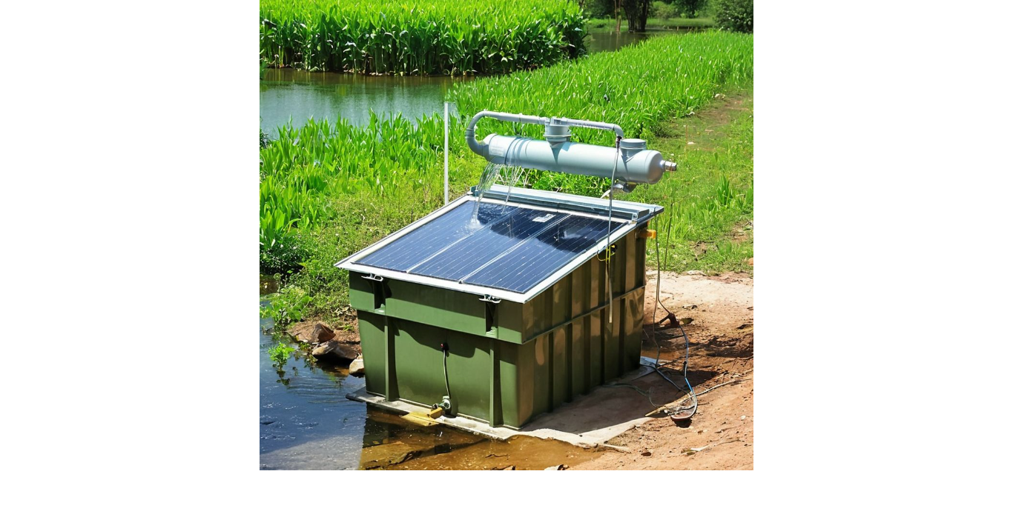

*Design Idea: Solar-Powered Water Purification System*

**1. Design Criteria**

**Criteria 1: At least use minimum 3 different approaches**

Analyze: Assess the quality and contamination levels of the water before and after purification.

Reduce: Utilize filtration to significantly decrease impurities and contaminants in the water.

Prevent: Implement measures to prevent recontamination of the purified water, such as secure storage tanks.

**Criteria 2: At least use 1 or 2 different technologies**

Solar technology: Use solar panels to generate electricity for the system.

Filtration technology: Use advanced filtration methods such as reverse osmosis to purify the water.

**Criteria 3: At least use 3 or more different devices**

Solar Panels: To harness solar energy.

Water Pumps: To move water through the system.

Filtration Units: To remove contaminants from the water.

Storage Tanks: To store the purified water.

**Criteria 4: At least list minimum 3 benefits**

Benefit 1: Provides a sustainable and renewable energy source.

Benefit 2: Improves health by providing clean drinking water.

Benefit 3: Reduces long-term operational costs due to the use of solar power.

**Criteria 5: At least list minimum 3 impacts**

Impact 1: Positive health impact by reducing waterborne diseases.

Impact 2: Environmental impact by reducing plastic bottle waste.

Impact 3: Social impact by improving the quality of life in the community.

**Criteria 6: At least list minimum 3 guiding principles**

Access & Equity: Ensures all community households have access to clean water.

Health & Safety: Provides a reliable source of safe drinking water, critical in emergency situations.

Sustainable Livelihoods: Maintains a high-quality, sustainable infrastructure with minimal environmental impact.

**Criteria 7: At least list minimum 2 constraints**

Constraint 1: High initial cost for installation of solar panels and filtration units.

Constraint 2: Regular maintenance required to ensure system efficiency.

**Benefits and Constraints:**

1. **What are the benefits/impact of your design idea?**

In general, solar-powered water purification systems offers the significant benefit as applying renewable energy source to generate clean water resource. As the same time, we also observe other benefits that have positive impacts on the Tanh Linh community. The system has satisfied requirements on: Access & Equity, Health & Safety and Sustainable Livelihoods.

1. **Does your design idea benefit the community in accordance**

**with the guidelines?**

Access & Equity:

In term of access and equity, solar-powered water purification systems has succeeded in reducing the potential gaps in access to clean water of Tanh Linh residents. The system has overcome the infrastructure challenge, clean water source is now accessible not only for nearby household but also available for remote residency. This means that no need for hand collecting water even for the most isolated area.

Health & Safety

In the aspect of health and safety, thanks to the solar-powered water purification system, the community can now abstain from one of the most significant risk of the world: waterborne infectious disease. In details, the system can avoid the potential factors causing infectious disease by applying multiple purification stages, such as filtration, reverse osmosis, and UV disinfection, guarantees the removal of harmful bacteria, viruses, and other contaminants. In result, Tanh Linh community can be able to minimize their healthcare cost.

Safety and Sustainable Livelihoods

Lastly, the system has positive impact on the environment of local area as well as contributing to the sustainable livelihoods. Regarding to the use of renewable energy resource, by utilizing the solar energy, water purification system reduce the reliance on fossil fuels, minimizing greenhouse gas emissions. Besides, the community is also empowered by the operation of this system: job related to maintenance and development will be created, building skills and also the responsibility of local residents for a sustainable future.

To sum up, solar-powered water purification systems is not just a technology providing clean water, it is also considered as an effective approach for enabling communities to create better futures by advancing equity, health, safety, and sustainable livelihoods.

1. **Any potential challenges (constraints) identified when using your design idea for present and future needs**

Implementing and maintaining a solar-powered water purification system in Tanh Linh town involves addressing several potential challenges. These challenges are critical for ensuring the system's effectiveness and sustainability in meeting both present and future needs.

1. High Initial Cost

- The upfront investment required for the procurement and installation of solar panels, water pumps, filtration units, and storage tanks is substantial. This high initial cost may be a barrier to implementation.

2. Regular Maintenance and Technical Expertise

- The system requires regular maintenance to ensure efficiency, including cleaning solar panels, replacing filters, and repairing any mechanical issues. Additionally, a lack of local technical expertise could hinder ongoing maintenance and troubleshooting.

3. Variability in Solar Energy Availability

- The efficiency of solar panels can be significantly affected by weather conditions such as cloudy days, rainy seasons, or prolonged periods of dust and pollution, leading to reduced energy production.

4. Environmental and Climatic Factors

- Environmental and climatic conditions, such as extreme weather events or seasonal variations, can damage the infrastructure or affect water availability.

5. Community Engagement and Acceptance

- Securing community acceptance and engagement is crucial for the success of the project. Resistance from local residents or a lack of involvement can hinder the implementation and sustainability of the system.

While the solar-powered water purification system offers significant benefits to the Tanh Linh community by providing clean water, improving health, and promoting sustainable livelihoods, addressing these potential challenges is essential for its successful implementation and long-term viability.